# Install a Windows 10 Virtual Machine (VM)

In this lab we will create a Windows 10 Virtual Machine. It will allow us to experiment without risk of damaging the OS on our host (hardware) machine.

# Windows 10 installation CD or ISO image

When installing a new Operating System (OS) on hardware, we need to be able to boot the computer from something other than the hard drive we will put the new OS on. Usually this is a CD-ROM or a USB Flash Drive, although it can also be a network storage location. Since we are creating a VM, it is easier to use a file called an ISO image, which is a copy of the information on a DVD in the format that DVDs use, ISO-9660 (it can be used to create a DVD, although we won’t need to do that.)

## Retrieve ISO file

An ISO file is a file in the ISO-9660 format that is used in DVDs. In days of old, those files were “burned” to DVDs and then the DVDs were used to install software. Now, most file systems can read ISO files and we install directly from them.

You can download a Windows 10 Evaluation ISO from this link.  
<https://www.microsoft.com/en-us/evalcenter/evaluate-windows-10-enterprise>

## A Note on Bootable Flash Drives

We will not need a bootable flash drive here, but in the future, you may want to boot from an OS installed on a flash drive. The simplest way to make a bootable drive using Windows is to download an application called Rufus (<https://rufus.akeo.ie/>). If you do not want to take the risk of downloading an application, you can make a bootable flash drive from the Windows command line. (See the “ISO Boot Disk” file in Unit 0 of Canvas, or go here: <https://betanews.com/2015/07/29/how-to-create-a-bootable-windows-10-usb-drive/>.) Copying large files to a flash drive, or installing from a flash drive, will be much faster if you use USB 3.0 (blue plastic inside connector) instead of USB 2.0 (red plastic inside connector) flash drives.

# Create a new VM

Open VMware Workstation Player and select File > New Virtual Machine.  
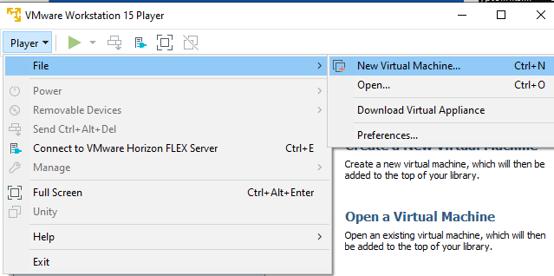

Select “I will install the operating system later.” We will install the OS manually rather than use VMware’s “Easy Install” wizard. The installation fails when you use the wizard because we do not have a license key for the Windows 10 Evaluation version. We install without a license and the installation is good for 90 days.

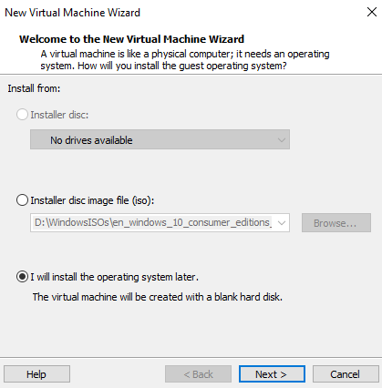

We want to tell VMware that the VM will be Windows 10 x64.  
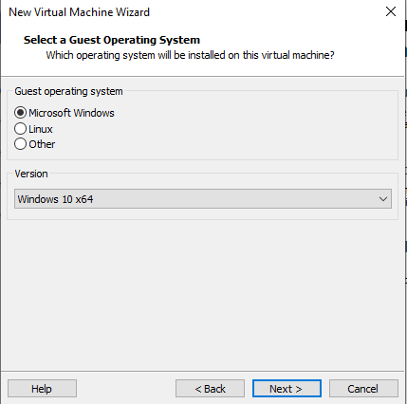

Give the VM a name and tell VMware where to save the VM’s files. (Once you have several VMs, you will be happier if the VM name includes the month and year you made it.) By default, it creates a “Virtual Machines” directory in your My Documents folder, which is fine.  
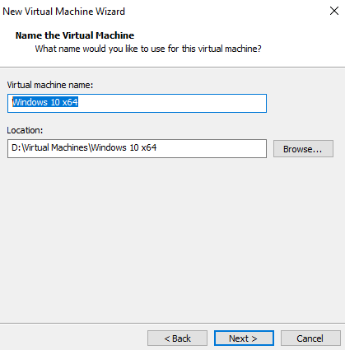

The Maximum disk size (GB) can be left at 60 unless you are short on disk space. Allow VMware to split the disk into multiple files.  
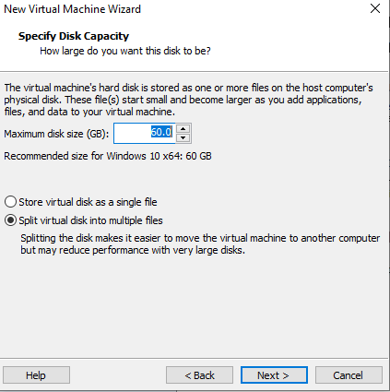

Select Customize Hardware and increase the memory for the VM to 4 GB. VMs usually run faster with more memory, as long as your host machine has enough memory. The classroom computers have 8 GB of RAM, so 4 GB should be a safe choice for the VM.  
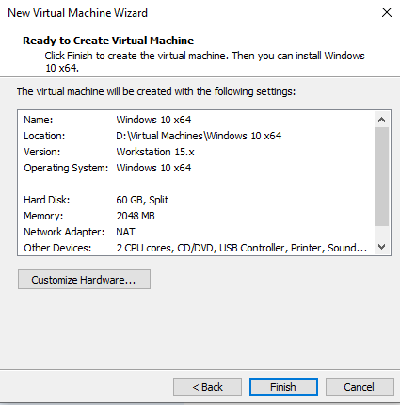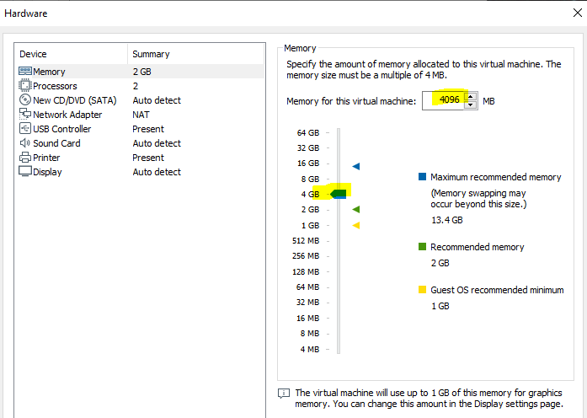

# Set the VM to boot from your ISO file

If we were installing on hardware, we would have to set the BIOS so the computer boots from our media, either the DVD or flash drive. With a VM, we need to tell the VM to boot from our ISO file. If you get errors later on that the hard disk or installation media could not be found, there was a problem with this step. You can always come back and assign the CD/DVD drive to the ISO you downloaded. Make sure that “connected at boot at power on” is checked. If the VM is already running check “connected” as well.

Select the VM you just created in VMware Player and choose File > Manage > Virtual Machine Settings.  
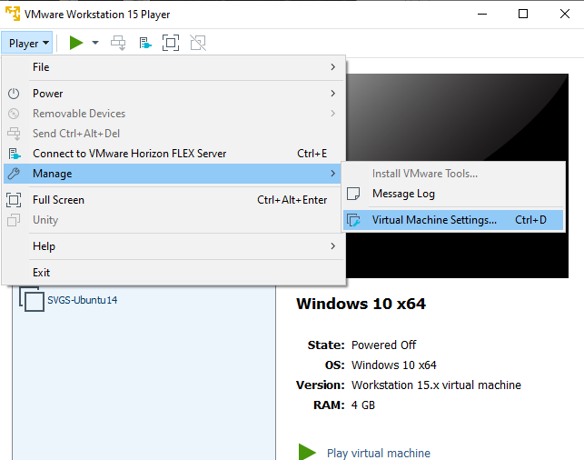

Select CD/DVD and “Use ISO image file.” Browse to the location where you stored your ISO file and select OK.  
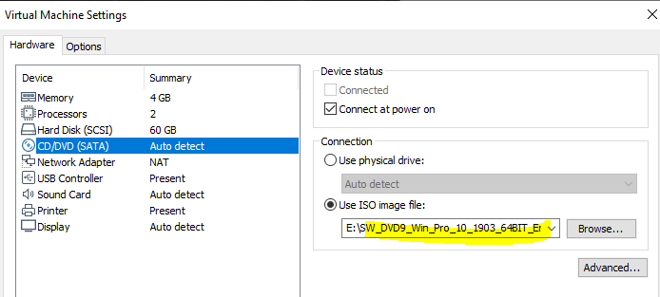

# Boot the VM from the ISO file and Install Windows 10

Select “Play Virtual Machine.” When the VM starts it should detect the ISO and boot from it. If it does, it will display “Press any key to boot from CD or DVD.” Press any key before the message disappears. (There are old jokes that will contain, “My keyboard does not have an ‘Any Key’.” Do not fall for them.)  
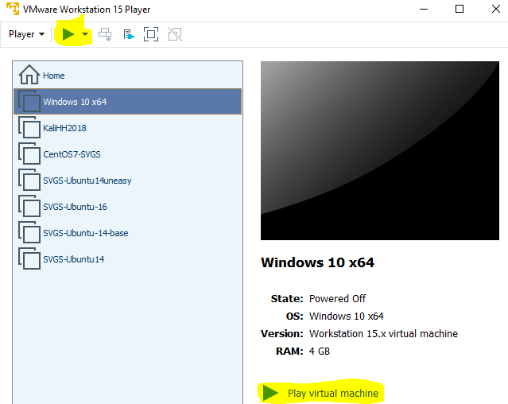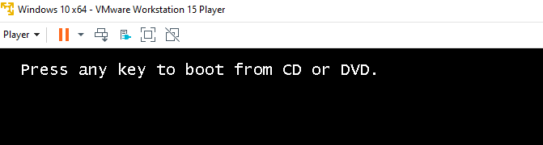

if you do not see the any key message, make sure the CD/DVD is connected and set to the correct file.  
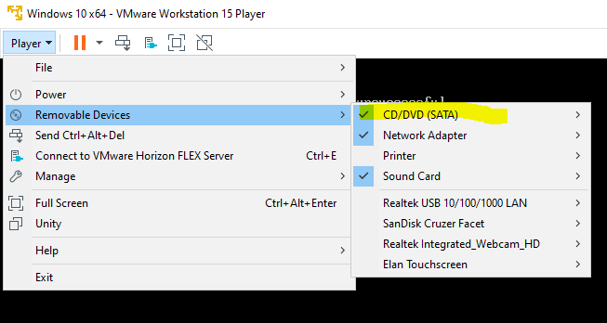

Note: The VM may steal your mouse cursor. If you find you cannot move your cursor select Control-Alt to free it. Later when VMware tools are installed on the VM, you will not have this problem.

With luck, the computer will load a simple installer OS from the CD and you will see this. After clicking Next, tell the program to install now.

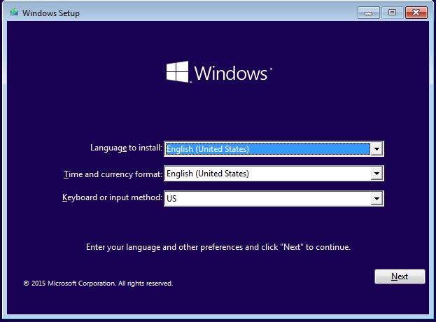 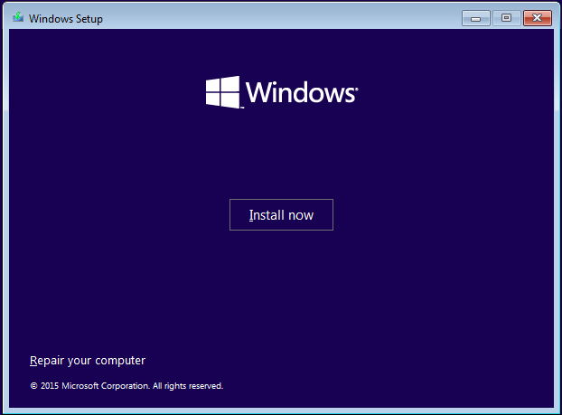

We can choose anything, so we might as well pick Windows 10 Enterprise.  
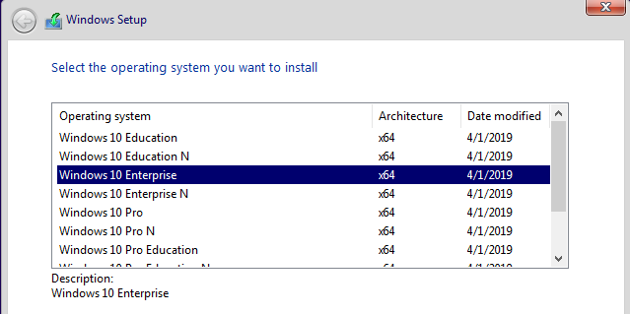

We will not show every screen, but the next one is misleading and needs some discussion.

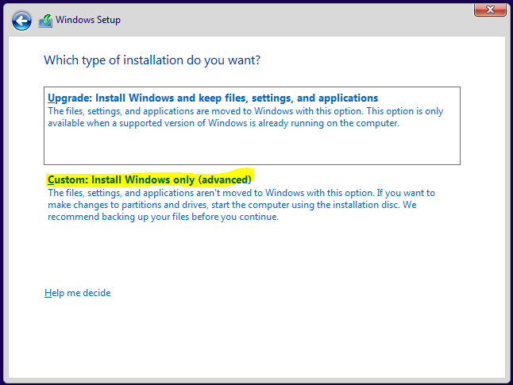

We need the option to Install Windows, not Upgrade. I assume this is “advanced” because it will overwrite the previous installation and destroy the information that is currently on the hard disk. Since our virtual hard disk is empty, that is not a problem.

# Configure Windows

When the VM boots it will try to get you to use a Microsoft online account to log in to the VM. That works, but I prefer to use an account that is local to the VM. We will not be joining the VM to a Windows Domain this time, but it is the only choice that winds up where we want to be. (An Active Directory Domain is the method that Windows uses to control large numbers of computers at once, offering things like central login. Corporate computers are in a domain, so uses can log in to any (almost) computer with their corporate account and corporate IT staff can control the computers.) Select “Domain join instead.”

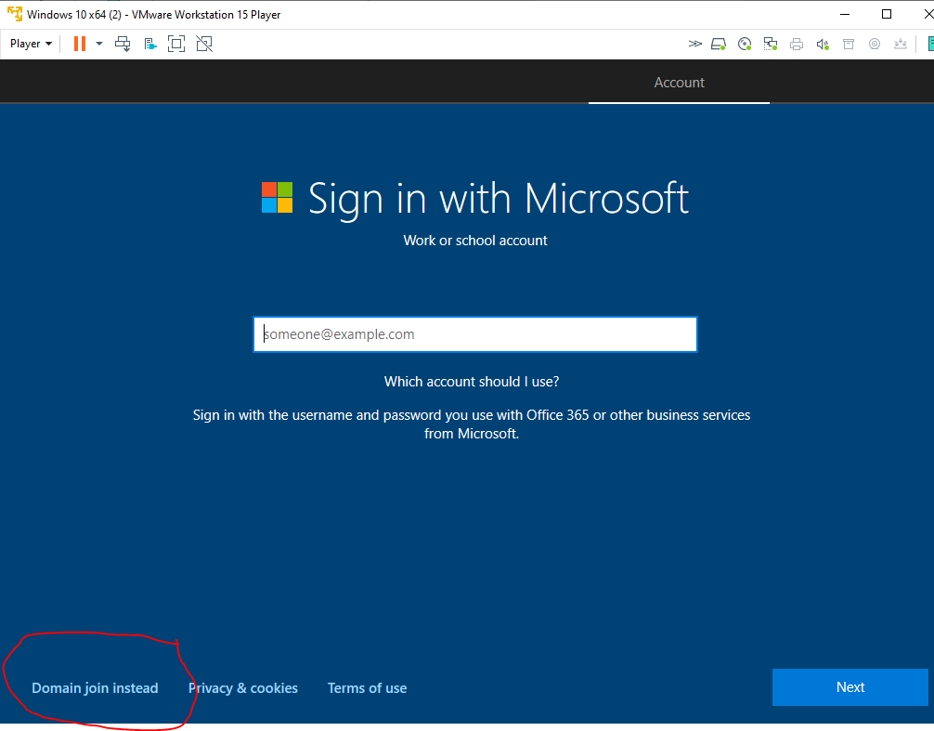

Microsoft tries to force us to use an account on their system to log in to the computer. Instead, select “Skip this step.”

Create your account. The username can be whatever you want, within reason. Keep in mind that faculty or your parents may see your username, so it is best to pick something that is not embarrassing. Make sure you can remember it.  
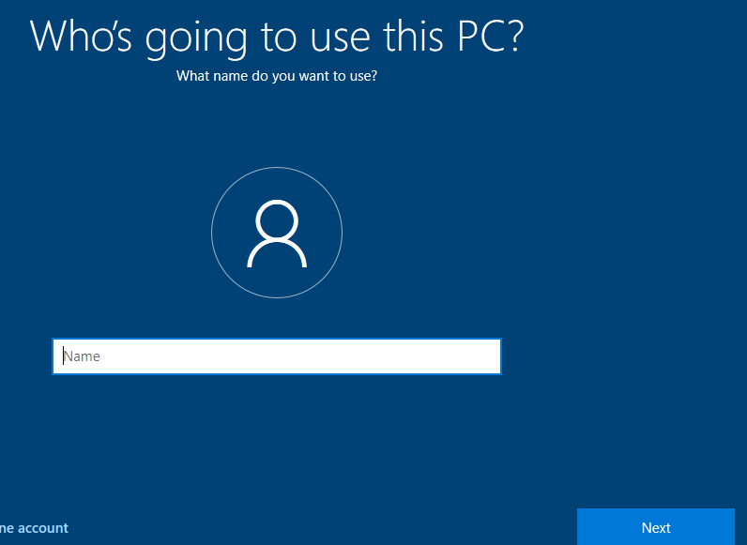

Most people will not be able to see the password, so you have more flexibility here. It is amazing how many of the passwords we see in lists of credentials from compromised servers are profane (no need to do that, however.) For your VM, it is ok to use a simple password that you can remember. You will log in and out of the VM repeatedly and the VM will only be used for labs, not for personal browsing.

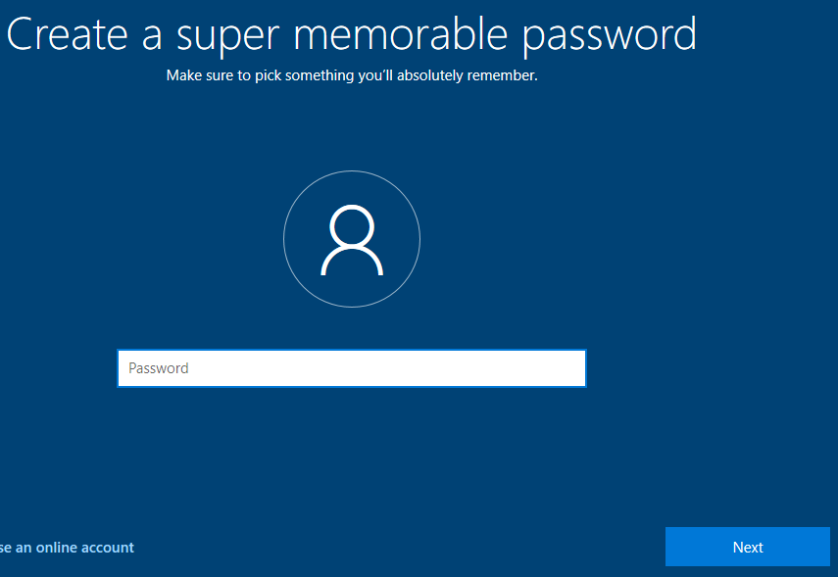

# Activate (License) Windows

If this were not an evaluation version, there would be a message at the bottom saying you need to activate Windows. You would have to enter a license key. Skip ahead to “Update Your VM” since we have an evaluation version.

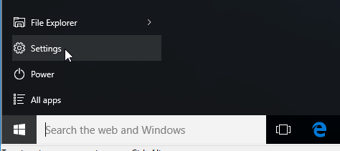 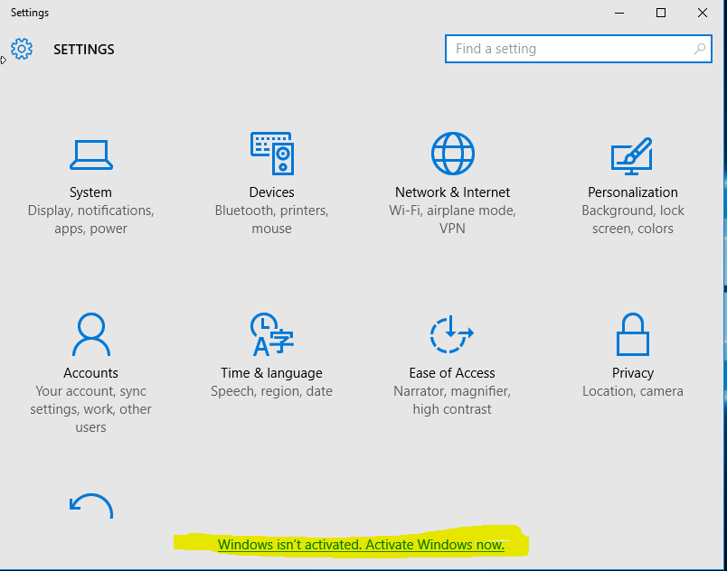

Select “Change product key” and enter the key your instructor gives you. This key belongs to SVGS, so **do not** copy it for your personal use. We will have other keys provided to us by Cyber Patriots that we can use for personal copies.

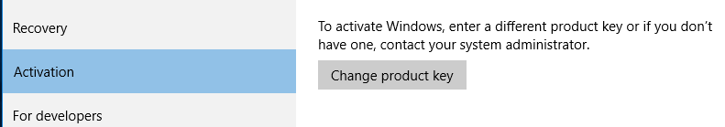

# Update your VM

Most vendors, including Microsoft, provide software updates on a monthly or as needed basis. Sometimes these updates, or patches, fix serious remote code execution vulnerabilities. It is often difficult to tell which patches must be installed immediately, so it is best to install all patches regularlly. There is a small risk in installing patches, as sometimes they break things. Large companies often test new patches for a few days before installing them. Some users wait a few days and watch their Internet feeds for reports of problems, but do not wait long!

Select settings, then Updates and Security (at the bottom.)  
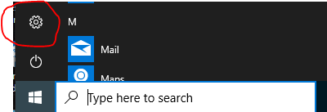 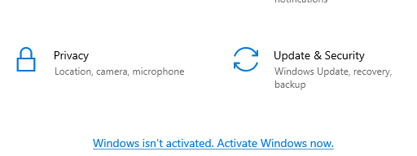

Click “Check for Updates” and install any outstanding updates.  
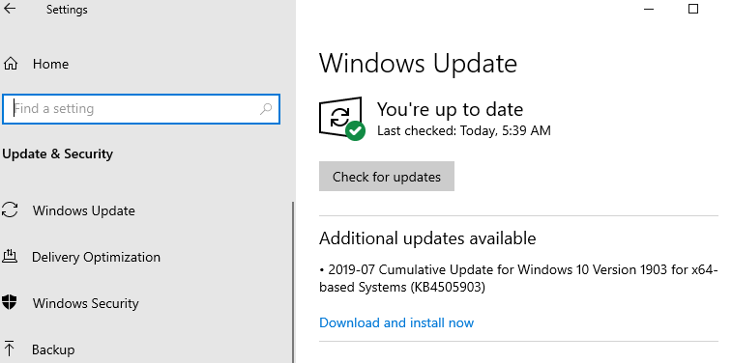

# **HAND IN**

When you are successful in getting the Windows 10 installed and running, submit a screenshot so I know you did it.